# **AWS EC2 SERVICE**

Step 1: Login into the aws account and then open management console and open ec2 service

Step 2: choose the N. Virginia region from the region menu

Step 3: Now we have to create an instance so to create an instance click on launch instance now a new wizard opens

Step 4 : As shown in the figure give a name to the instance and the select the virtual machine image

Step 5: VMI is a template that contains the software configuration i.e operating system,application server required to launch the instance , here amazon linux is selected .

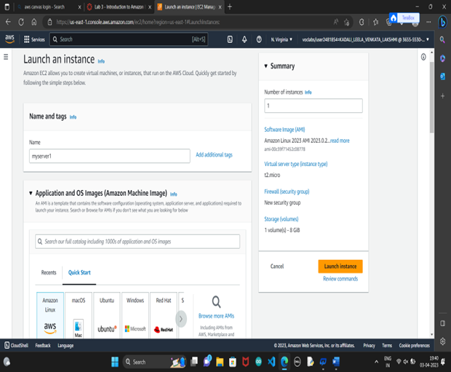

Step 6 : Now Select an instance type that meets your computing, memory, networking, or storage needs.

Step 7 : Now create a key pair ,this key pair is used to securely connect to your instance. After key pair is given a .pem file is downloaded . click on create pair

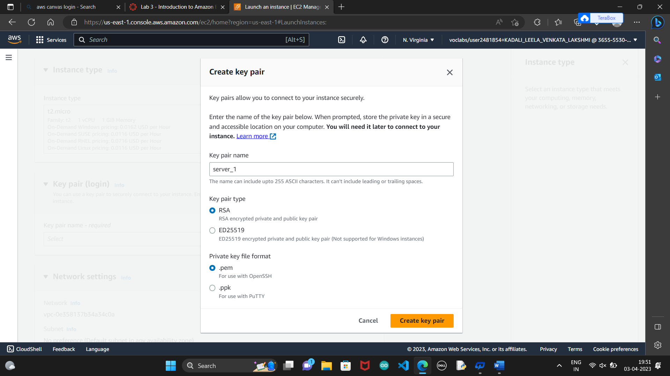

Step 8: In Network settings we can see that an default VPC is assigned and also an public IP is given and a default security group is also provided with port 22 open .

Step 9 :configure storage is nothing but an elastic block store so by default 8gb is provided we can modify it by adding a new volumes

Step 10 : Now click on launch instance then the instance will be created ,Now we have to connect to the instance

Step 11:After the instance get connected terminate the instance

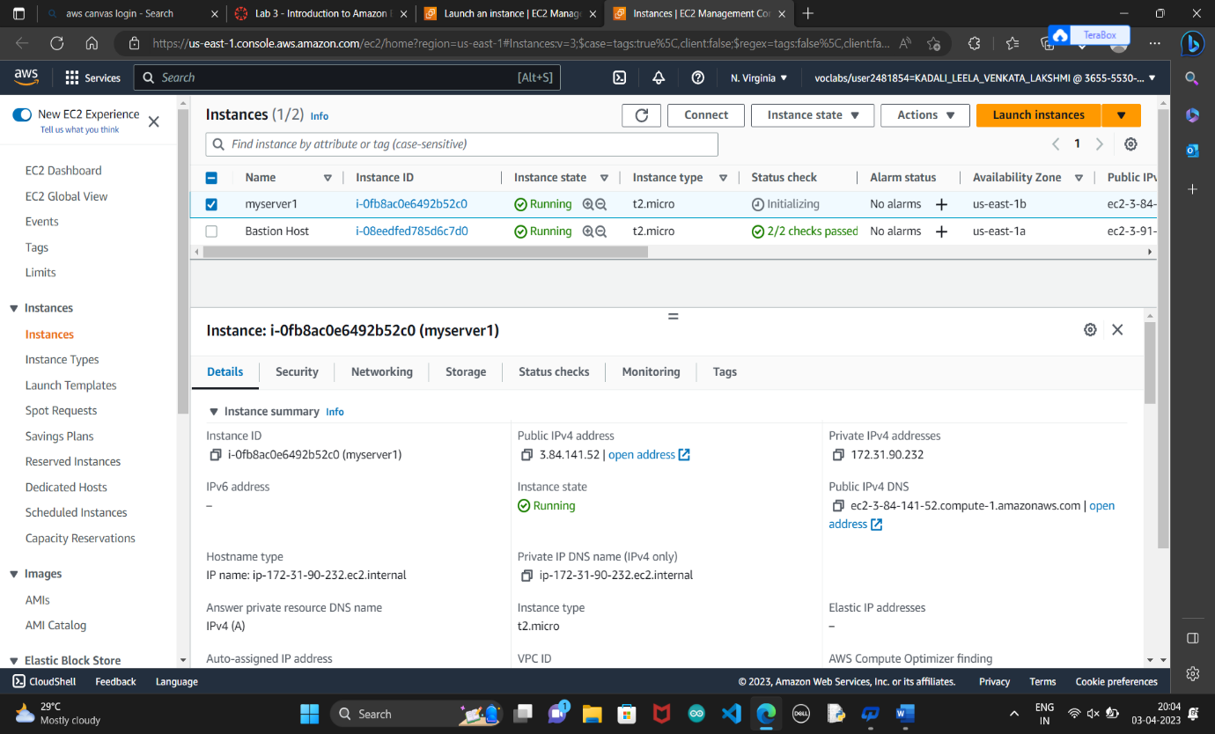

**SECURITY GROUPS**

Now we are going to create an security group . so here by opening the ports we can establish the connection inbetween the servers

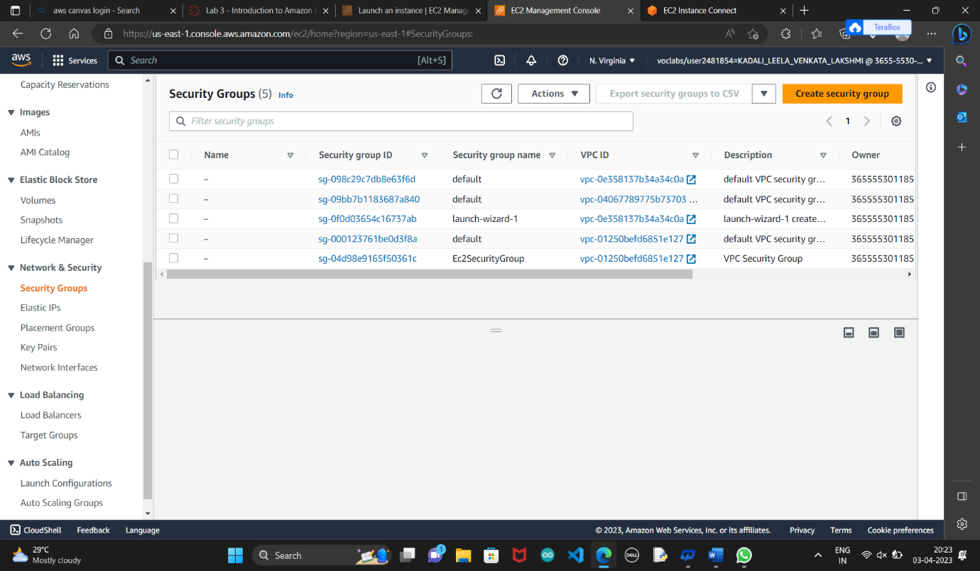

Step 1: In order to create the security group click on create security groups

Step 2 : Now give a security name and create inbound and outbound rules

Step3: to create security rules you have to specify

1.The protocol to allow

2.The range of ports to allow

3. The traffic source to allow for inbound rules, or the traffic destination to allow for outbound rules

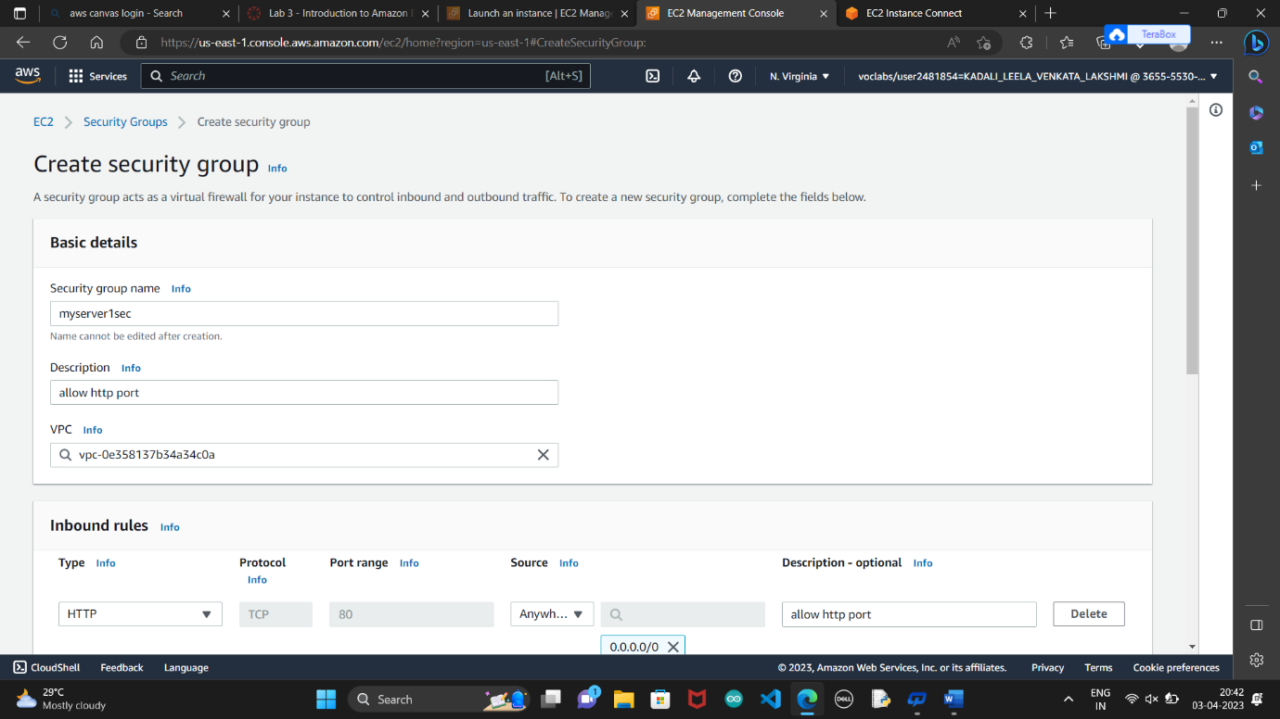

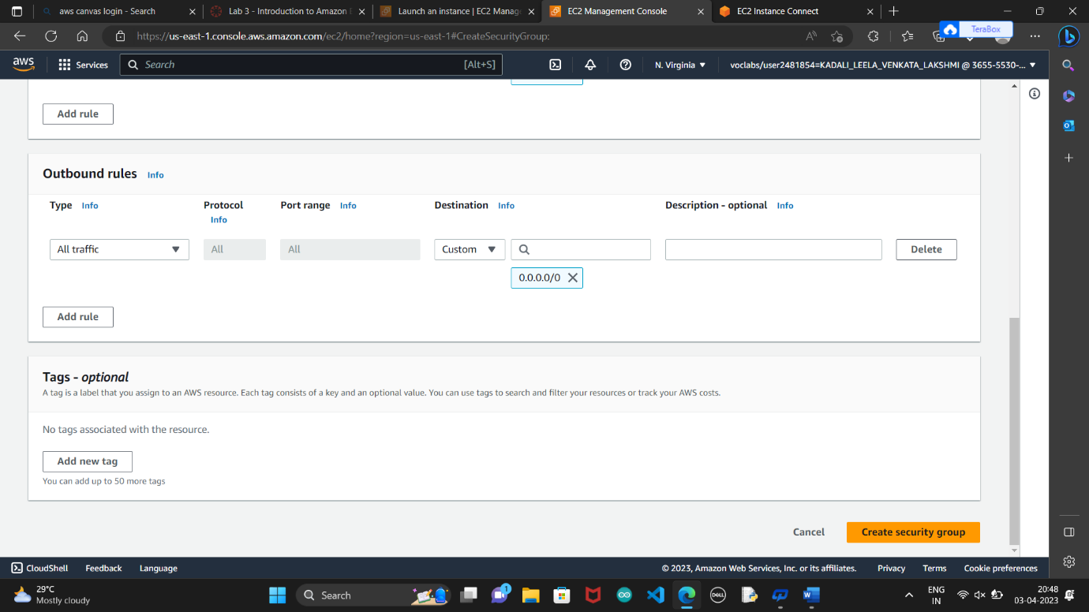

Step 4 : click on create security group then a security group is created